1. **CREATE A VISUALIZATION OF OVERALL INVENTORY TRENDS**

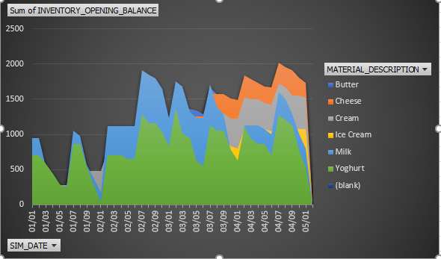

**In the first round, the inventory was handled smoothly by the team. The team member who was supervising the inventory process analyzed the number of products transported, stored, and sold in each of the regions. She communicated to us her findings and we simultaneously made the stock transfers, analyzed sales report and decreased the prices of the products that were not being sold in a particular region. However, for the other three rounds our team mostly did a push transfer even for regions with no sale instead of a pull operation causing inventory and revenue loss.**

1. **SELECT AND VISUALIZE A KPI FOR INVENTORY**

**The KPI which I selected to visualize the market trends and inventory processes is the number of days the company incurred losses as the total warehouse goods exceeded 4000.**

**I have included two illustrations for this visualization.**

* **The total number of inventory goods on each day of the four rounds.**
* **As per logistics, if there are 1000 additional boxes beyond the base capacity of 4000 daily charge of 50 Euros would be applied for each of the 1000 boxes. A KPI graph showing the number of days the inventory had >=5000 boxes. I did not consider the days having 4000-4999 boxes as additional warehousing costs is only for 4000 + 1000 boxes.**

**Our team could use this measure to operate profitability by increasing/reducing prices and manage transportation strategies — push/pull — as per product demand and number of boxes in each storage location especially in the last two rounds where the company faced major losses. This data could help in making better decisions and avoid warehousing costs.**

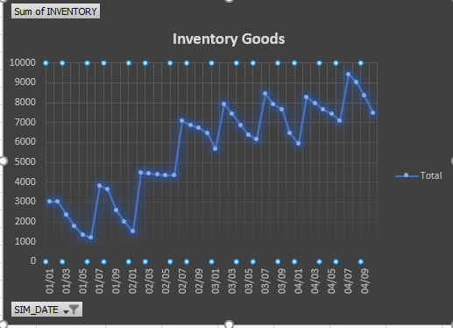

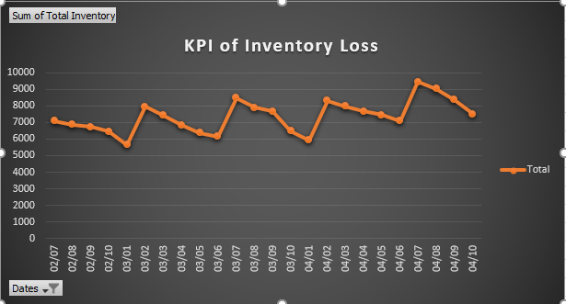

1. **SELECT AND VISUALIZE A KPI FOR SALES**

**To understand the company’s performance, I generated a KPI graph illustrating the number of transactions which were most profitable – CONTRIBUTION_MARGIN_PCT > = 0.12 — for each of the products**.

* **Figure 1 illustrates the number of transactions that took place in each of the regions – North, South and West for each of the products. As observed, Milk and yogurt were the products for which maximum transactions took place. This visualization could help the team to make profit out of milk and yogurt by increasing the prices.**

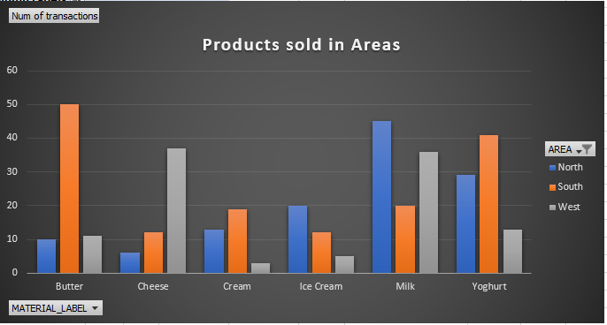

* **Produced two graphs to study the number of transactions (product wise) where contribution_margin > 0 and contribution_margin_pct > 0.1**

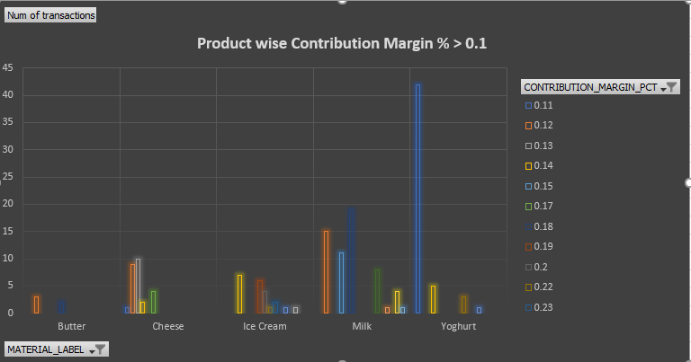

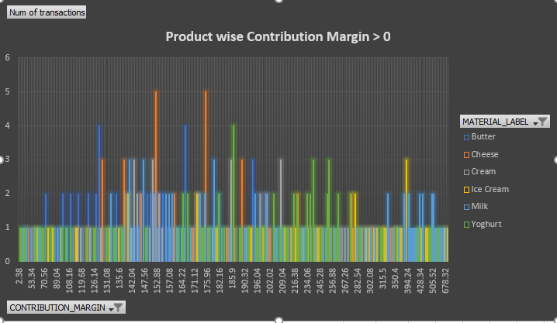

* **The following KPI graph for product profitability demonstrates that Milk and Yougurt have undergone maximum profitable transactions. This could help us to strategically plan the price ranges and stock transafers for these products thereby increasing company valuation**.

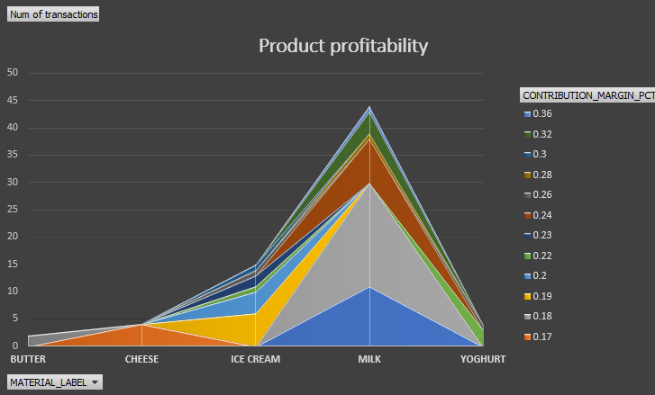

**SUMMARY**

**The three KPI visualizations gave an insight of which products were essential for the company, what processes could be improved to increase the business valuation and what factors should be considered to drive decision-making.**